Sprint 2

Mike Yang  
myang383@gatech.edu

# Design

## Project Summary

The project is focused on creating a mobile application that allows users to record food items and breaks them down into their nutritional values, including macro and micro nutrients. The workflow of the app would be that once a user has the app, they could enter in common recipes or foods that the application could break down into the relevant nutrients. Further development would be utilizing image recognition so in theory, a user would be able to take a picture of the menu or the food item, and the system would be able to break down the ingredients. After enough data had been gathered, the application could begin filtering out commonly obtained goals (most likely things such as calcium or Vitamin C) and begin showing less frequently obtained nutrients, such as trace minerals or amino acids. To recognize the nutrients in an item, the app maintains its own database, which to streamline entries, will usually be an aggregate of small variations in every item (ex granny smith apples vs fuji apples).

## Tools and Technology

The following technologies are planned on being used:

* Kotlin
* Java – combined with the above for backend
* Open Source GitHub projects that utilize image recognition
  + Snap-n-Eat
  + Calorie Mama API
* Machine-learning – filter out commonly obtained goals to focus on less often achieved nutritional requirements

## Data Sources

* Food Data Central – combination of several different profiles
  + Foundation Foods
  + Food and Nutrient Database for Dietray Studides
  + National Nutrient Database for SR Legacy References
  + USDA Branded Foods
  + Experimental foods

These is the current only database that is intended to be used at this moment. Data could be accessed through API or a CSV. Once development starts, that decision will be made.

## Diagrams

Figure 1 Front-end logic

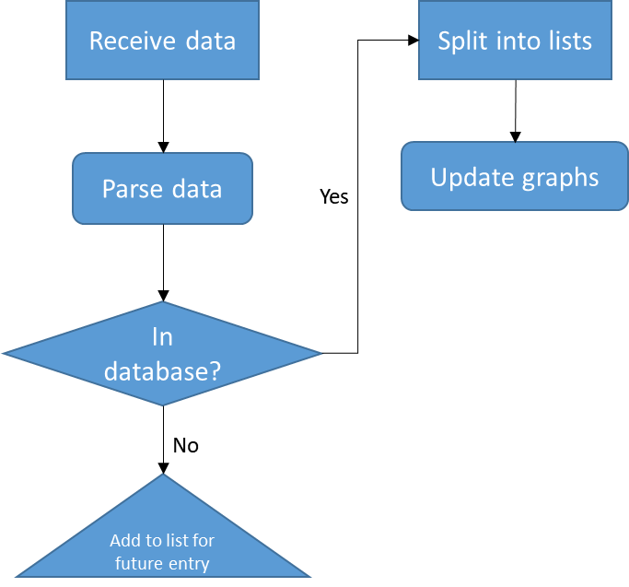

Figure 2 Back end logic for user entry

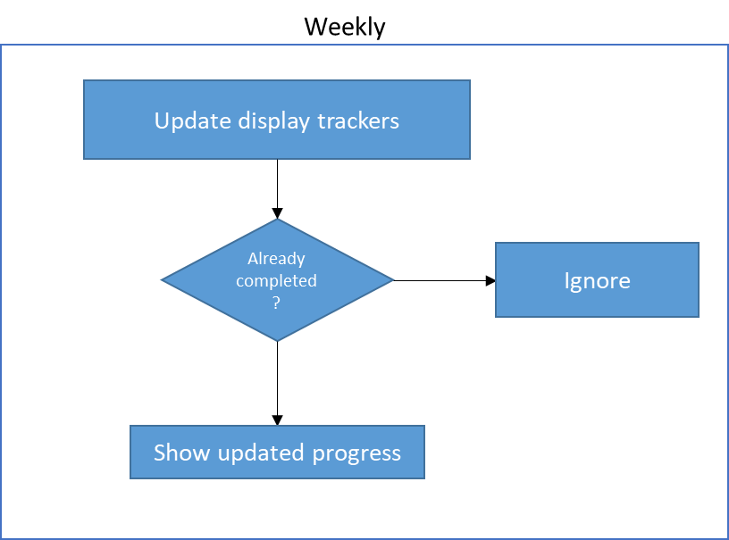

Figure 3 Logic checks as user uses app over time

## Screen Mock-ups

Figure 4 - Main application screen

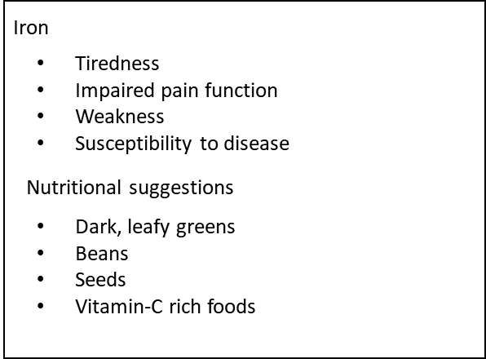

Figure 5 - Secondary screen for information

# Implementation Plan

## Project Tasks and Timeline and Risks

Placed into Planner: <https://tasks.office.com/gtvault.onmicrosoft.com/Home/PlanViews/yBCyrWkp0EOthVLl0frD12QAE5T6?Type=PlanLink&Channel=Link&CreatedTime=637516241542600000>

# References

1. Magalhães, G. (2019, December 10). gabrielilharco/snap-n-eat. GitHub. <https://github.com/gabrielilharco/snap-n-eat>
2. Rendulic, I. (2017, December 25). igorrendulic/food_recognition_with_calorie_mama. GitHub. <https://github.com/igorrendulic/food_recognition_with_calorie_mama>